Use pure Scrapy code to write a scraper for the following site:

[https://www.marionfl.org/agencies-departments/departments-facilities-offices/building-safety](https://www.marionfl.org/agencies-departments/departments-facilities-offices/building-safety/permit-inspections)

[/permit-inspections](https://www.marionfl.org/agencies-departments/departments-facilities-offices/building-safety/permit-inspections)

Click on “By Permit, Parcel or Address”, which will take you to the search page:

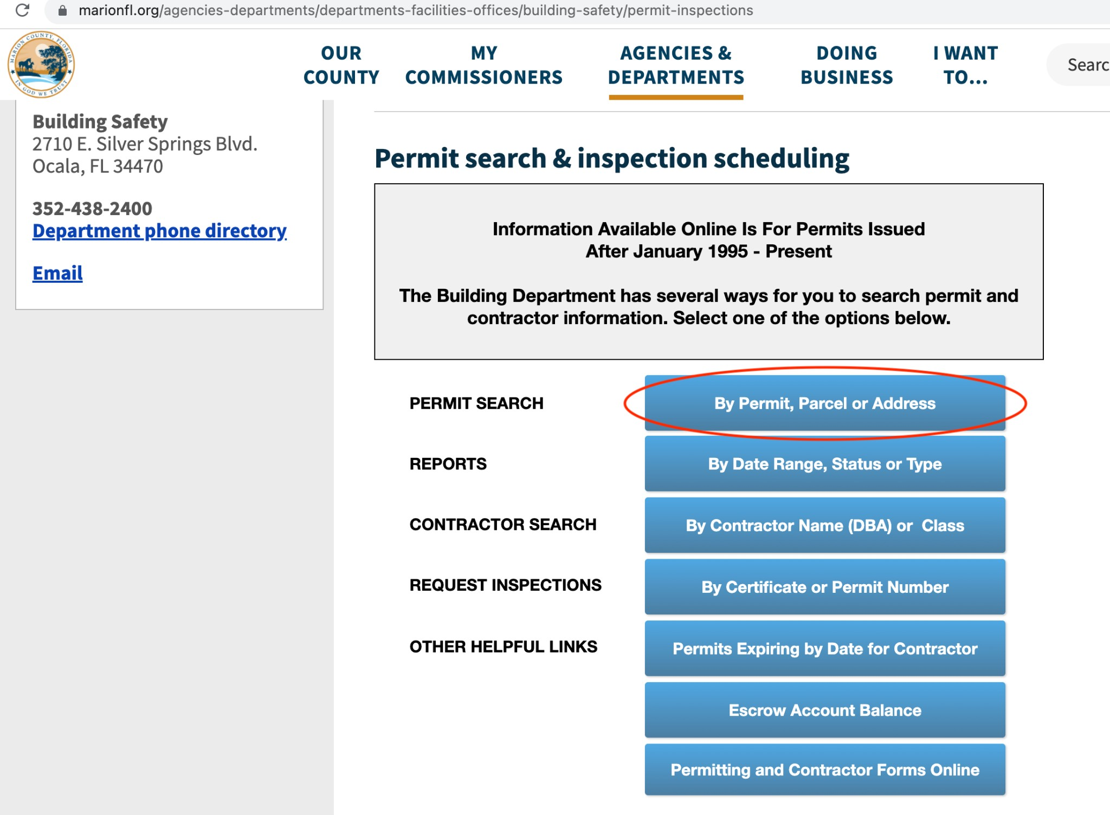

Next, you can search by Permit number, address, or Parcel ID:

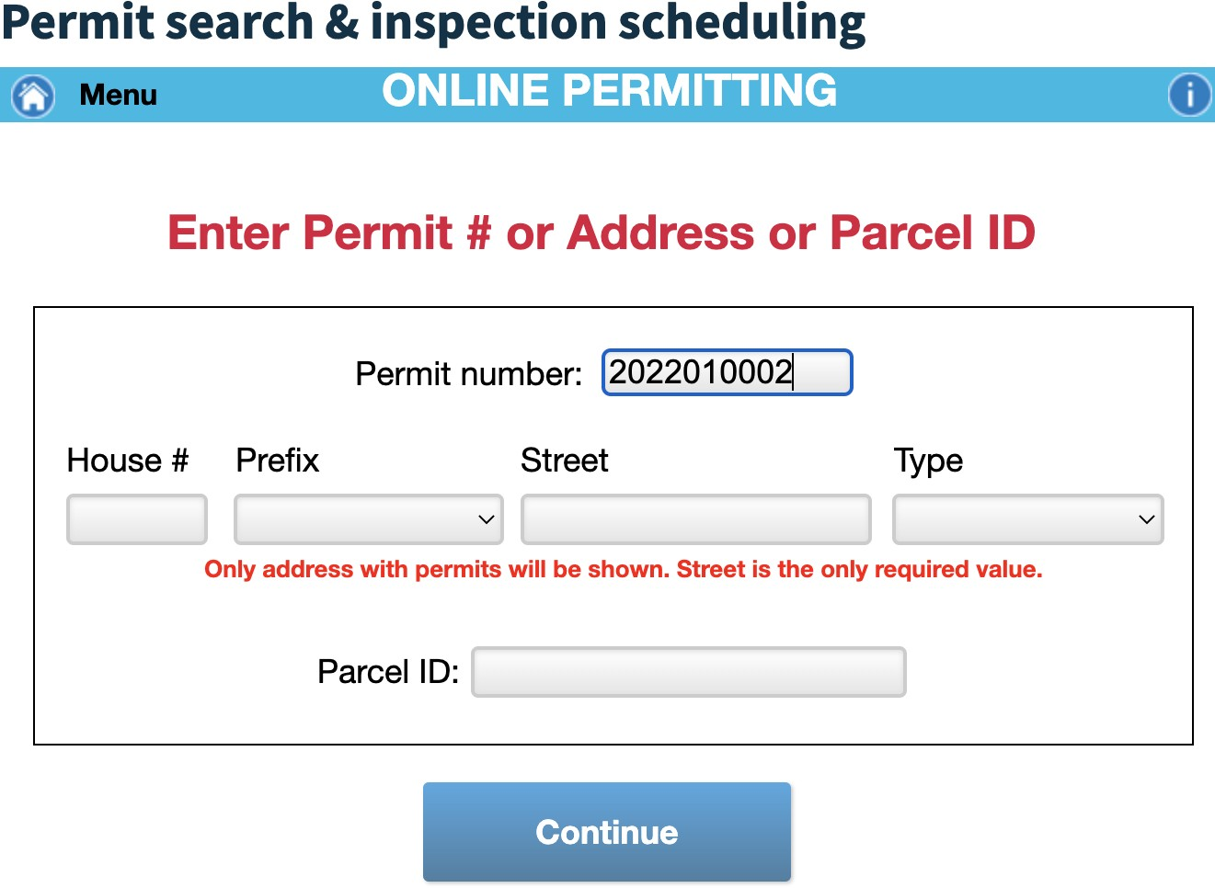

Use permit number 2022010002 as an example to get Permit Details:

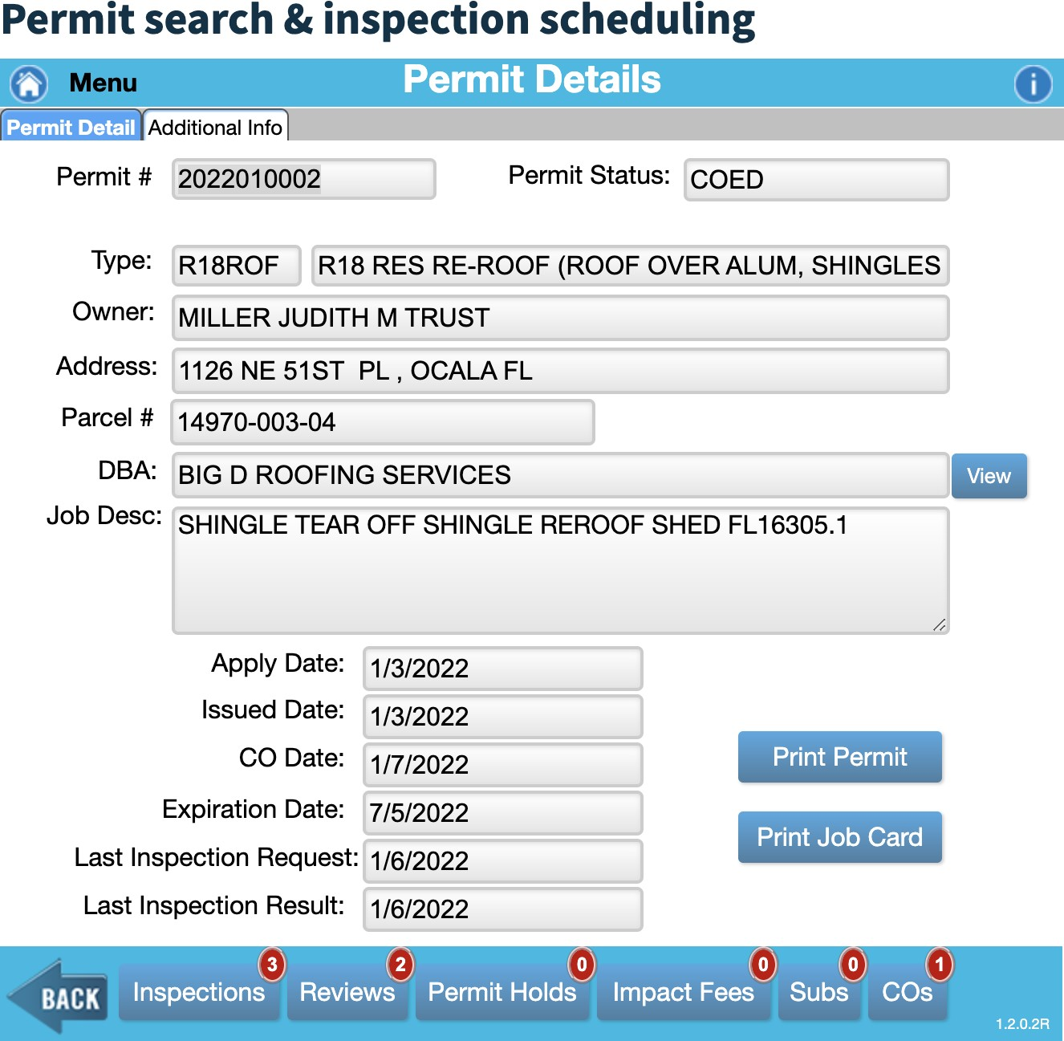

Note: we do not have a reference list for permit numbers, addresses, or Parcel ID’s, so we encourage you to search by guessing the ID, which may be a counter that consists of a

1. digit year, 2-digit month, and 4-digit id.

The scraper should search for a given permit number, drill down into every tab and capture all the information available on the page in JSON format, including values that are missing or not well-formed.

* 1. Extracted sample data of at least 100 records (this website has hundreds of thousands)